**Annex E**

**Final Report**

**Contractor**

|  |  |
| --- | --- |
| Name of the Local Organization providing the report: | Maasai Pastoralist Development Organization |
| Address: | P.O.Box 13987 ARUSHA  Mobile phone +255 (0) 787 975 196  Email: [**lebarakalaizer2@yahoo.com**](mailto:lebarakalaizer2@yahoo.com)**,** [**mpdolareto2005@gmail.com**](mailto:mpdolareto2005@gmail.com) |
| Person in charge of the final report: | Amani Sekino |

**Identification of the project**

|  |  |
| --- | --- |
| Name of the project: | Sustainable forest management to secure multiple benefits in Essimingor and Selela forests conservation in Monduli. |
| MOA/Agreement number: | TAN/SGP/OP6/Y5/ICCA-GSI/2021/05 |
| Type of project: | ICCA-GSI Phase 1 |
| Location: | Monduli. |
| Start-up Date: 1st AUGUST 2022 Completion Date: 28th February 2023 | |

Please provide results on the specific project indicators selected at MOA stage (according to the Project Indicators selected as per Annex A of the Project Proposal on mandatory global environmental and socio-economic benefits as well as optional project indicators:

|  |  |  |
| --- | --- | --- |
| **GEF SGP OP7 Core Global Environmental Indicators (at least one is required)** | | |
| Please checkmark applicable ones | GEF OP7 Core Global Environmental Indicators | Please provide results achieved (in numbers) |
| ☐ | Marine protected areas under improved management effectiveness (hectares) | _________ |
| ☐ | Area of degraded agricultural lands restored (hectares) | _________ |
| ☐ | Area of landscapes under improved management to benefit biodiversity (hectares) | _________ |
| ☐ | Area of landscapes under sustainable land management in production systems (hectares) | _________ |
| ☐ | Area of marine habitat under improved practices to benefit biodiversity (hectares; excluding protected areas) | _________ |
| ☐ | Solid and liquid Persistent Organic Pollutants (POPs) and POPs containing materials and products removed or disposed (tons) | _________ |
| ☐ | Number of direct beneficiaries of SGP intervention | _________ |
|  | Number of Women | _________ |
|  | Number of Men | _________ |

|  |  |  |
| --- | --- | --- |
| **GEF SGP OP7 Socio Economic Indicators** | | |
| Please checkmark applicable ones | **Socio- Economic Indicators** | **Please provide results achieved** |
| ☐ | Number of direct beneficiaries with improved livelihoods and well-being | _________ |
| ☐ | Does the project develop capacities of organizations (CSOs/CBOs) or people? | Yes/ No |
| ☐ | If Yes, number of organizations with improved capacities (CSOs/ CBOs)? | _________ |
| ☐ | If Yes, number of people with improved capacities? | _________ |
| Please checkmark applicable ones | **Gender Indicators** | **Please provide results achieved (Indicate NO or NO)** |
| ☐ | Was the project led by women? | Yes/ No |
| ☐ | Did the project contribute to equal access to and control of natural resources of women and men? | Yes/ No |
| ☐ | Did the project improve the participation and decision-making of women in natural resource governance? | Yes/ No |
| ☐ | Did the project target socio-economic benefits and services for women | Yes/ No |

**Budget and finance**

|  |  |
| --- | --- |
| Total Project Cost: |  |
| Amount received under this Agreement: |  |
| Amount received from other sources of funding: |  |
| Contribution of the Local Organization or the recipient community: [please estimate cash and in-kind contribution] |  |

**Activities and outputs**

**Introduction.**

This report summarizes the implementation of activities funded by UNDP SGP and coordinated by the Tanzania Natural Resources Association under implementation of MPDO-LARETO. The main objective of the intervention was to contribute to the sustainable management and conservation of Essimingor Forest Reserve through empowerment and active participation of adjacent local communities to develop accountability systems for sustainable forest management.

.

UNDP/SGP is seeks to advance forest management and community empowerment efforts, improve coordination and reduce resources exploitation as well as increasing household income through diversify economy. By strengthening the capacity of community and increasing their cooperate activities with forest management authority, the media and other development partners, MPDO –LARETO hopes to facilitate a more effective local response to forest management.

Activities in this third quarter included facilitate the collection of 5,000 acacias trees to be planted in Losimingori forest, Selela forest and other community institution like schools toward improving forest status at community level.

**Describe key activities and outputs performed under this agreement:**

1. Project inception meeting at District Level

Project Inception meeting was done on 9th September 2022 at Makuyuni Monduli District. The inception meeting was conducted at District level whereby community representatives, traditional leaders, ngo’s, media, governmental officials, from ministry of community development, gender, women and special groups, TFS, and forest officers attended. After the implementation of the activity more than 31 people benefited direct and more than 1000 indirectly hence the project gained public interest and simplifies the implementation of other activities. This activity was conducted after Government endorsement which took long time and delay of project inception to its stakeholders from donor to implementing organization. This activity was done by Maasai Pastoralist Development Organization (MPDO) in collaboration with experts from the Government Particularly Forest Department to explore the service done by MPDO-LARETO in project targeted wards of Selela and Lepurko. This training was participated with 31 people (12Fe 19Me). The meeting brought different stakeholders to know that MPDO is carrying out Sustainable forest management to secure multiple benefits in Essimingor and Selela forests conservation project funded by UNDP and coordinated by Tanzania Natural Resource Forum (TNRF).

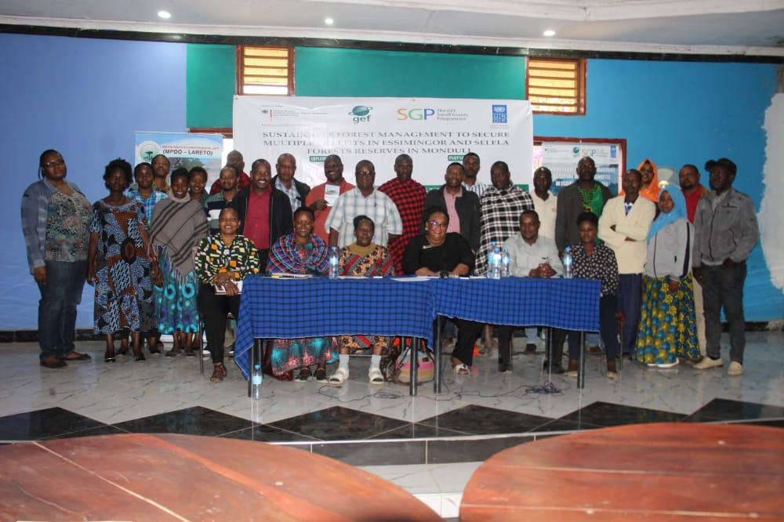

At the middle is Regional Community Development Officer (RDCO) Ms. Blantina Nkini who was the guest of honor during inauguration ceremony.

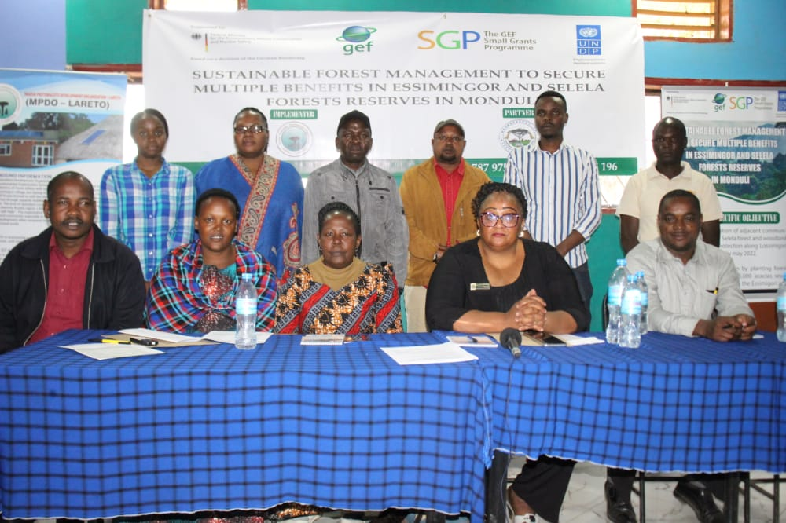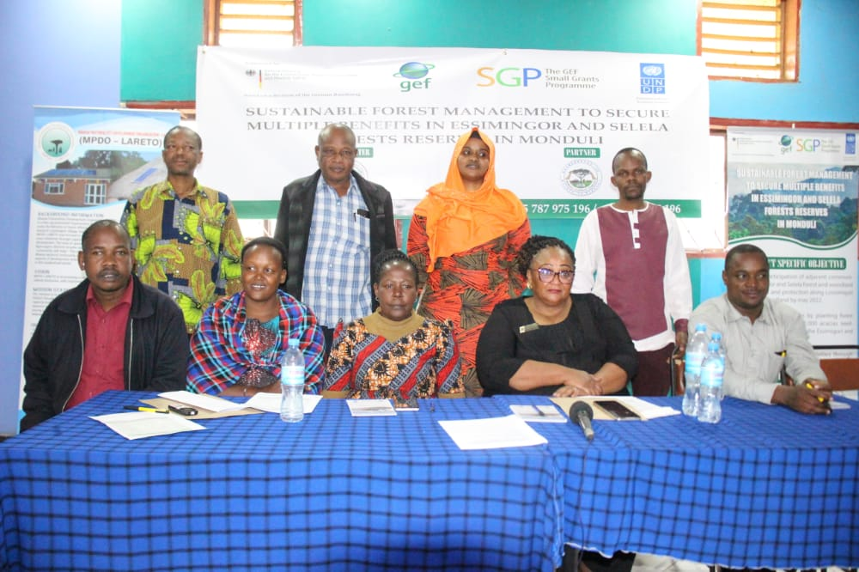

This is a group photo between Guest of honor, MPDO staff and NGOS representatives during Inception meeting

Inception meeting involved few organizations who are implementing different projects funded by UNDP. Among them are TNRF, MAIPAC, SILAO, MIMUTIE, BAWAKIMO and ANGONET. Again we invited government officials including RDCO, DC, DED, TFS and DCDO.

**Media Engagement during inception meeting.**

Radio engagement has been conducted to deliver land use plans message to community in large to understand their rights based approach to ensure that community will stand up themselves to protect their environment. We used a maasai radio called Orkonerai Radio Service which available in 94.4 FM. After message deliverance we have received several call from community members who are on line by that time. Again we succeeded to use ITV program to demonstrate the challenges brought by human forest exploitation as shown through good reporter Alfani Lihundi and the clip has already shared in our group whatsap. Radio dialogue and TV programs has reached a big number of beneficiaries indirect by listerning and direct through ITV watching.

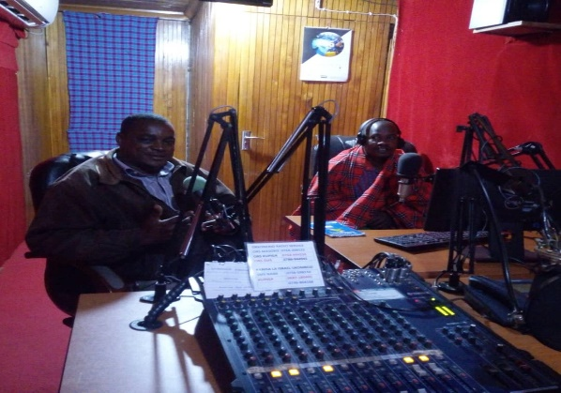

**Radio dialogue at Orkonerei Radio Service Simanjiro**

* 1. **Facilitating sensitization meeting for JFM and Review, recover and train Village Natural Resources Management Committees in 3 villages with gender equity.**

This meeting was conducted in Selela ward and participated by involving Village Natural Resources Management Committees from both project wards. The population participated to this wonderful training is 15 people from Losimingori, Selela and Mbaashi Villages. This activity done through facilitation from Monduli District Forest Officer Miss. Happiness Msaki who is expert on forest resource management and she familiar with different bylaws govern the VNRMC

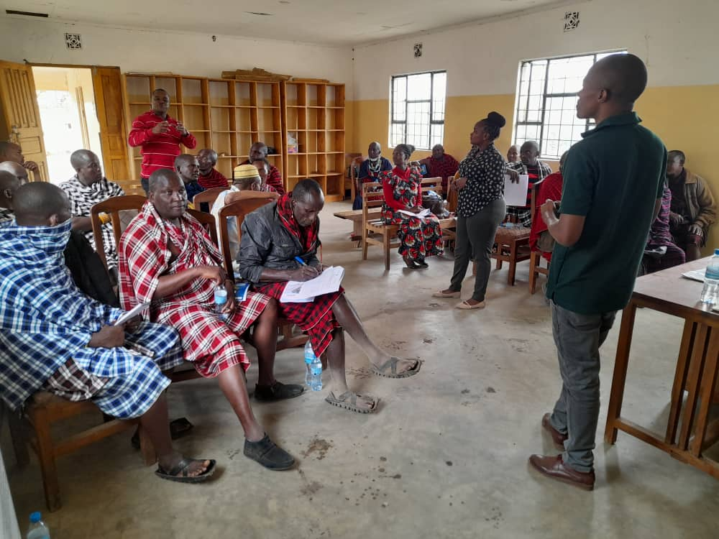

The picture showing Miss. Happiness Msaki the facilitator from Monduli District Council during VNRMC capacity Building training at Selela

* 1. **Training trainees on JFM to review the existing and develop new management plans, by-laws and joint management agreements in the 3 villages.**

Participation is aim to enable/empower the people so that they may obtain greater control over the planning process, resources and their lives. Through participation, rural communities and local institutions may search their own ways to sustainable development, based on their real needs, skills and strengths.

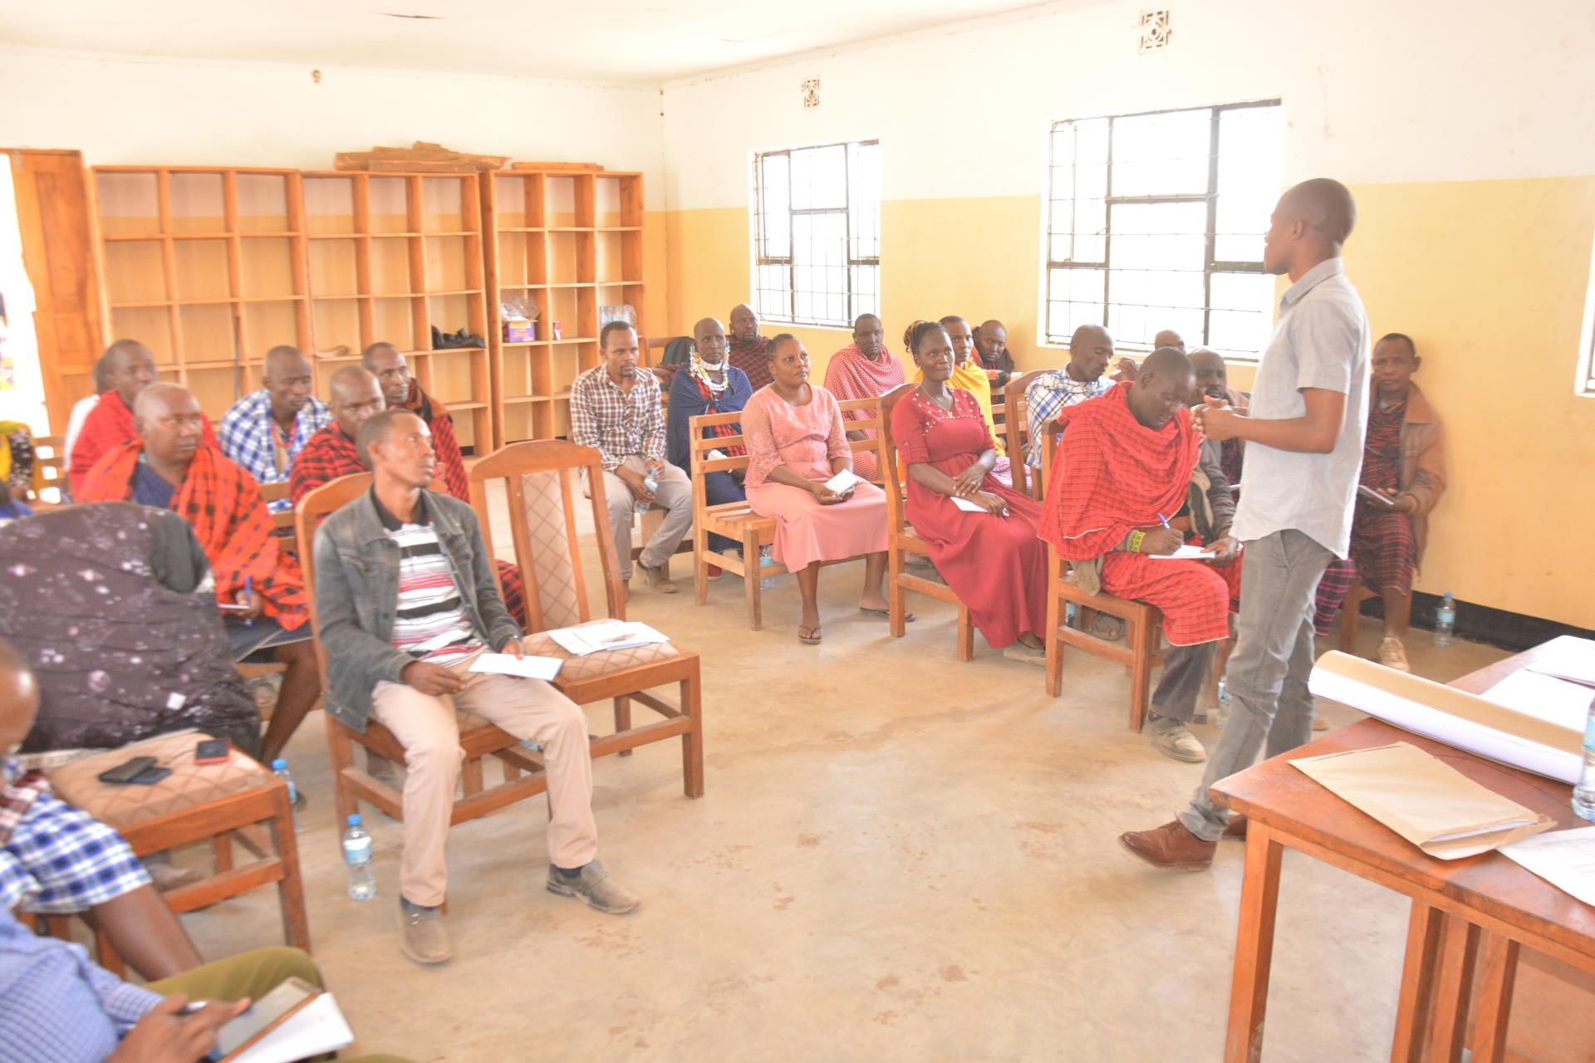

Unlike conventional, top-down oriented planning methods, data collection through participatory techniques concentrates on the data which are most relevant, and therefore cheaper and faster. The participatory planning process requires more time than conventional planning because of the consultation and negotiation process by the stakeholders involved. However, this assures that the stakeholders will feel the plans are their own, and that they are ready to implement and maintain them.

1. **Undertake preparations of land use plans by using village land use planning guidelines from the Ministry of Lands in the three target villages**

This meetings was conducted to Village Natural Resource Committee Members from Losimingori and Selela villages to improve their functionalities As a result, village land use planning, administration and management is an important tool for natural resource management and sustainable rural development. There is an increasing evidence that the use and management of land resources are better addressed through a participatory and integrated approach. The Guidelines for Participatory Village Land Use Planning and Management of 1998 came into operation even before the enactment of the Land Act Cap 113 (1999) and the Village Land Act Cap 114 (1999) among many other Laws which are the basis of Land Administration and Management. Also to date the Government of Tanzania has put in place two pieces of legislation namely the Environmental Management Act Cap 191 (2004) and the Land Use Planning Act, No. 6 of 2007 both of which acknowledge the critical role for a harmonized strategy for effective planning and management of land and its natural resources.

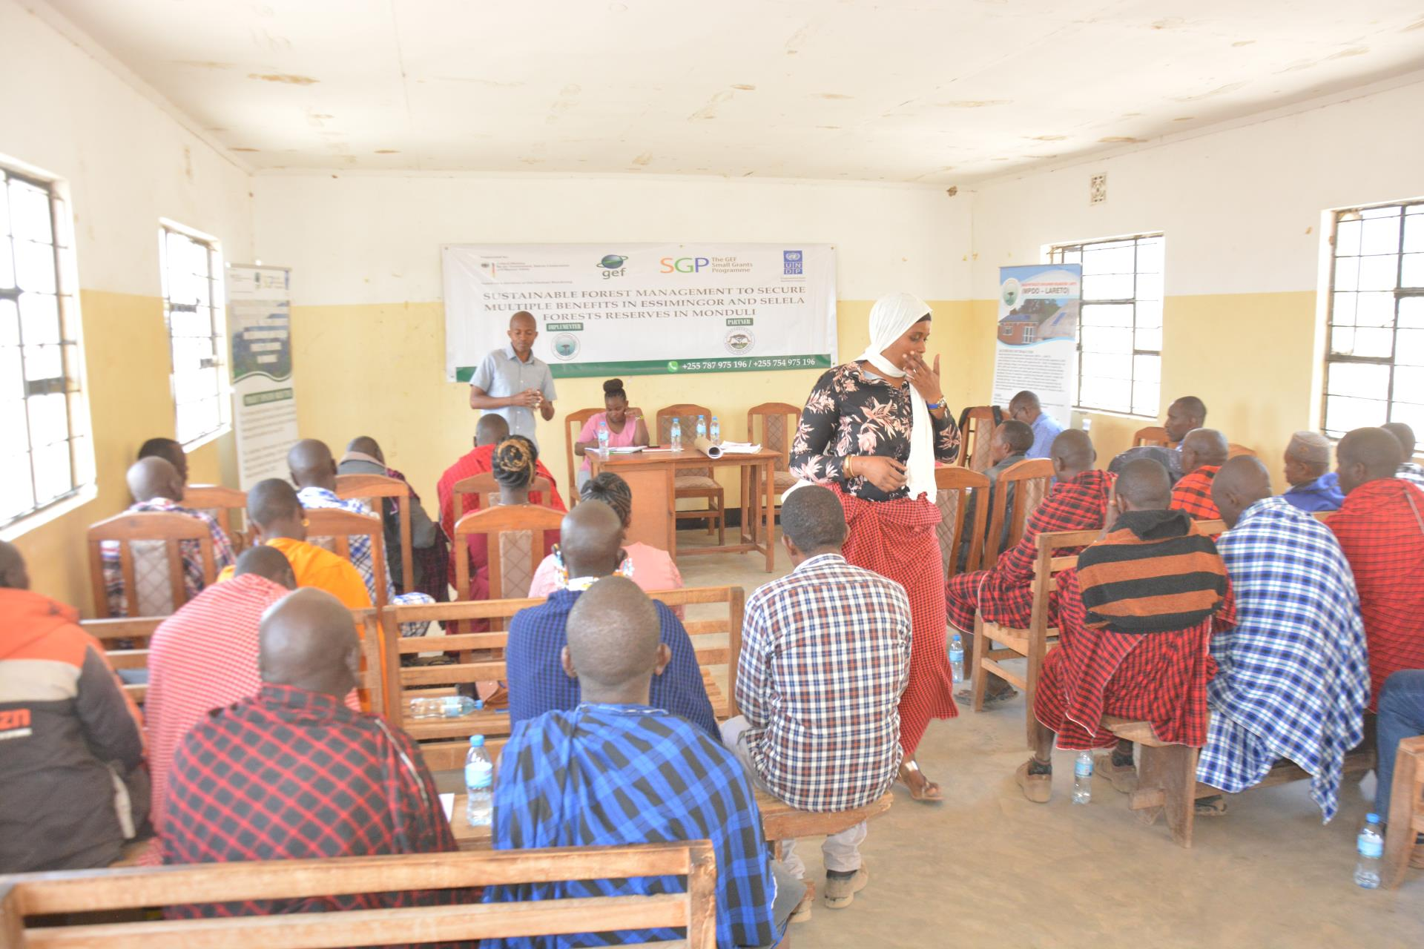

The Manager for **Tanzania Forest Service** Agency (**TFS**) Mr. Godlisten Koka and Miss. Happy Msaki from Monduli District Forest Department where the facilitators during of land use plans trainings. TFS is an Executive Agency with mandate for the management of national forest reserves in Tanzania so the project funded by the **GEF / SMALL GRANTS PROGRAMME** is being implemented with other stakeholders like government.

1. **Support 2 women groups for beekeeping activities**

This activity was conducted to 30 women of two groups from project areas of Selela and Losimingori wards.

The main objectives of the project is to contribute to the alleviation of poverty in rural areas of Losimingori and Selela, contribute to the improvement of health and social-economic conditions in the vulnerable groups of the Maasai community as well to promote sustainable development initiatives, creativity, self-reliance and responsibility in the community by:-

* To provide 28 hives and train a core contingent of 30 local community members in the practice of beekeeping.
* To introduce 30 local people from Naiti village and Selela Village to beekeeping as a means of providing personal and collective income and reducing local poverty with a targeted 80% adoption rate.
* Improvement of local health standards through the use of bee products such as honey.

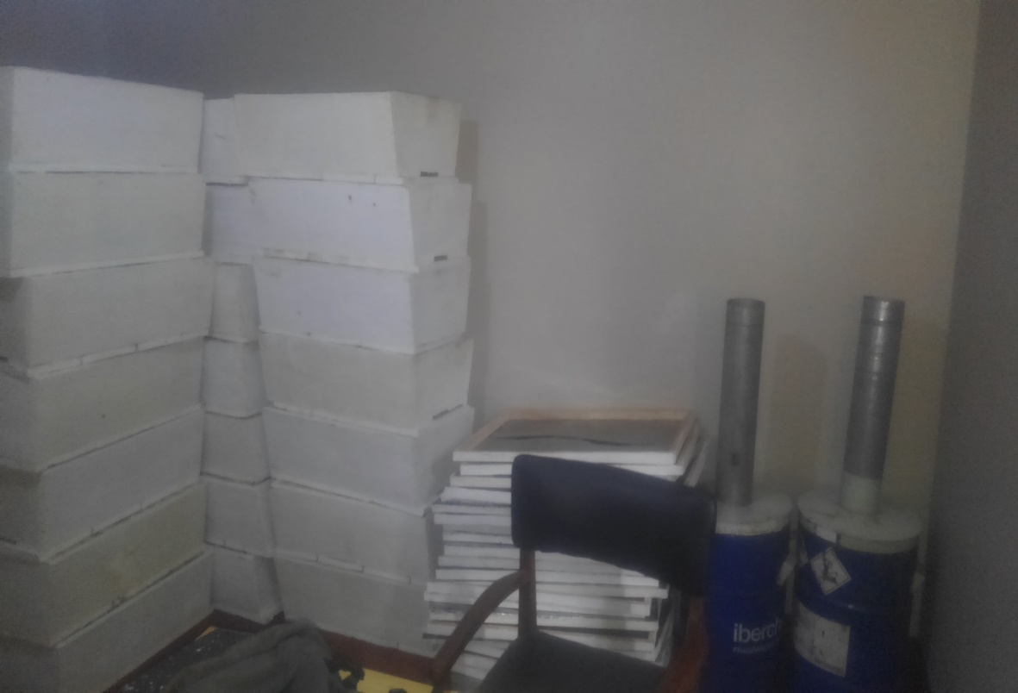

**This picture showing beehives and alternative charcoal machines distributed to two women groups.**

Community income specifically women groups has increased after starting making charcoals from solid wastes this is after training two women groups from Irkisima and Selela and provide them with special machines for charcoal making from solid wastes. These women groups were also provided with bee hives and are expecting to earn more income from bee hives after harvesting in six months to come.

* 1. **Training women groups on how to make stoves which use alternative charcoals made from waste papers and plastic.**

The training on how to make stoves which use alternative charcoals made from waste papers and plastic to 30 women from two groups of **Nanyori group from Losimingori and Inyuat E Maa from Selela**. This alternative form of charcoal is helping the women access a source of energy that help women to reduce the use of firewood to avoid forest exploitation. The use of recycled dust has also helped to improve cleanliness and to reduce littering in the community, since every piece of dust is put to good use. Previously, uncollected heaps of dust posed a danger to health especially in the rainy season; heaps of garbage are a good breeding ground for diseases such as cholera, which was happening in most crowded cities of the country.

1. **Organize special training for Village Natural Resources Management Committee.**

Natural resources management (NRM) should therefore take into account the interests of all those who participate in, or are affected by, the management of a given common resource. Many NRM related problems (e.g. water use, soil erosion and forest depletion) spread beyond the borders of an individual farm and can be found across several farms, villages or watersheds. This may have impacts at the global level in terms of greenhouse emissions, biodiversity loss and desertification. These shared problems require the collective action of farmers and other users to improve the management of common resources in the ecosystem.

**Create awareness.** Awareness needs to be created at the village level on topics such as the following:

* The contribution of natural resources (land, forests, water body, wildlife, river basin, etc.) to villagers’ livelihoods
* Changing trends in the availability of natural resources, conflicts and likely situation in the future
* Opportunities for improving the current situation (such as group/organization formation and development, improved management of the soil, water, vegetation, agroforestry and other natural resources)
* The best options under local conditions, such as joint management with access rights to land, forests, rangeland and water resources
* The need for an NRM plan
* Who is best placed to guide the implementation of the options identified
* The way forward based on what is agreed upon.

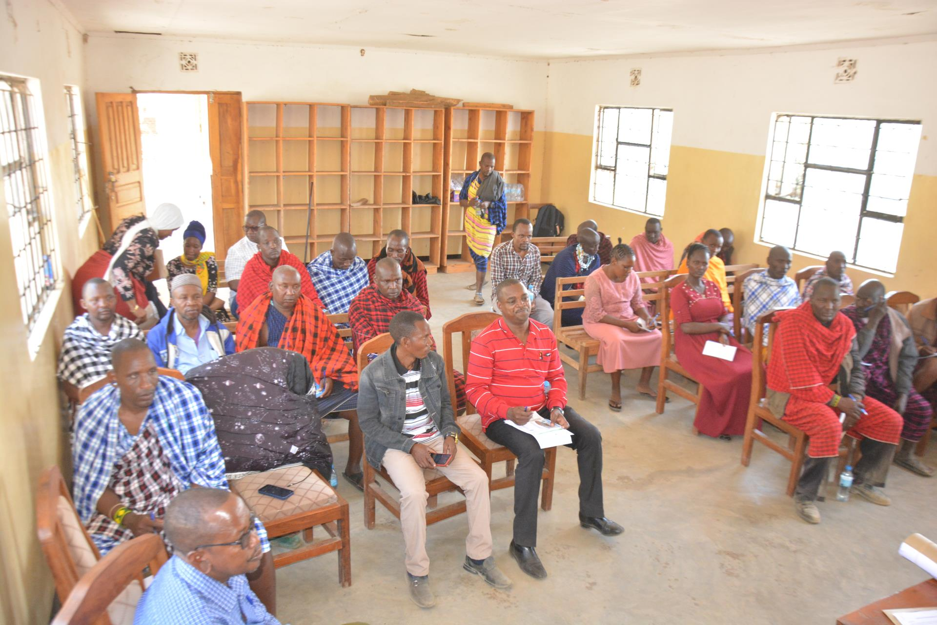

Village Natural Resources Management Committee members during the training at Selela Ward.

1. **Facilitate the collection of 4670 acacias trees to be planted in Losimingori forest, Selela forest and other community institution like schools.**

The expected results toward the above activity is “Reduced rates of 5,000 acacias trees cutting and occurrences of forest fire as per disturbance transect data, in areas of Lossimingor and Selela, adjacent to the 3 target adjacent villages”. This activity is well done in collaboration with other stakeholders like government, Tanzania Wildlife Authority (TAWA), Community and Tanzania Forest Services (TFS) to bring participatory means to all.

* 1. **Preparation and digging holes for planting trees in Losimingori and Selela forest.**

The MPDO management made a real and deep preparation of the forest trees pit digging in collaboration with government, Tanzania Wildlife Authority (TAWA), Community and Tanzania Forest Services (TFS). The director of the Maasai Pastoralist Development Organization Mr. LebarakaLaizer holding a reborn in his hand with the Manager of the Forestry Services Agency in the Monduli Zone Mr. Godlizen Koka. The aim of the reborn is to mark the areas where holes will be dug to plant trees in the Losimingori forest which is under the Tanzania Page 3 of 13 Forestry Services Agency

Holes dug ready to grow trees in the forest

MPDO team and soldiers inspecting the dug holes

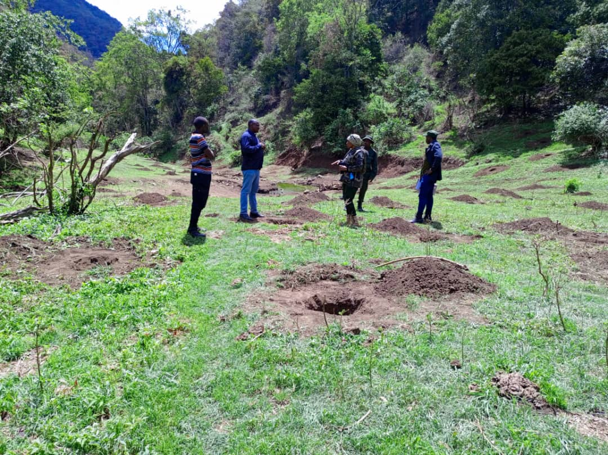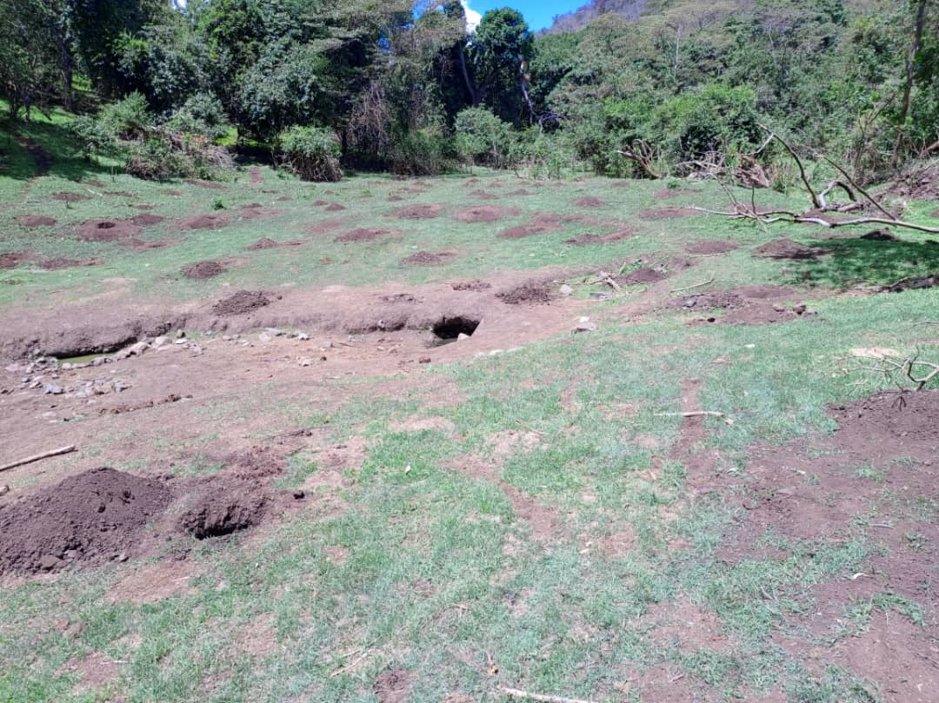

The implementation team of the Losimingori and Selela forest conservation project led by armed soldiers from the Tanzania Wildlife Authority (TAWA) and the Tanzania Forest Service Agency represented by Mr. Godlizen Koka who is the Regional Manager together entered the forest to see and inspect how the work of digging holes for planting trees has been done. The exercise of digging holes for planting trees in the Losimingori forest has been done within four days and eight hundred (800) holes have been completed. This project has been very difficult during its implementation due to the safety of human lives, especially the project implementers due to wild animals such as elephants, buffaloes and lions being too many in the forest. It should be noted that we have been able to restore water sources in the forest by 50% compared to the period before this project was funded by UNDP SGP and coordinated by the Tanzania Natural Resources Association. During the project designing we never thought if we would come to use armed soldiers in the implementation of our project which was inevitable for our safety but also it caused other things to change.

* 1. **Purchase of 4670 acacias trees.**

MPDO-LARETO under procurement committee with TFS Officer Mr. Abdul has purchased 5000 natural trees from one supplier in Arusha with the aim of planting them in the Losimingori and Selela forest areas as well as planting others in community areas such as primary and secondary schools. Analysis of 4670 purchased trees. After planting tree along the Losimingori and Selela forests, around public area like schools, churches, mosques, government institutions and water sources which was about to dry up has now started releasing water, new water sources has starting emerging. The behavior of people has also changed because the number of cattle grazing in forests and water sources has reduced for 100%. Before the project implementation at least 200 cattle was reported monthly but now only **zero** are reported monthly

This is the spring of the canyon no. 7 after intervention

This is the spring of the canyon no. 7 before intervention

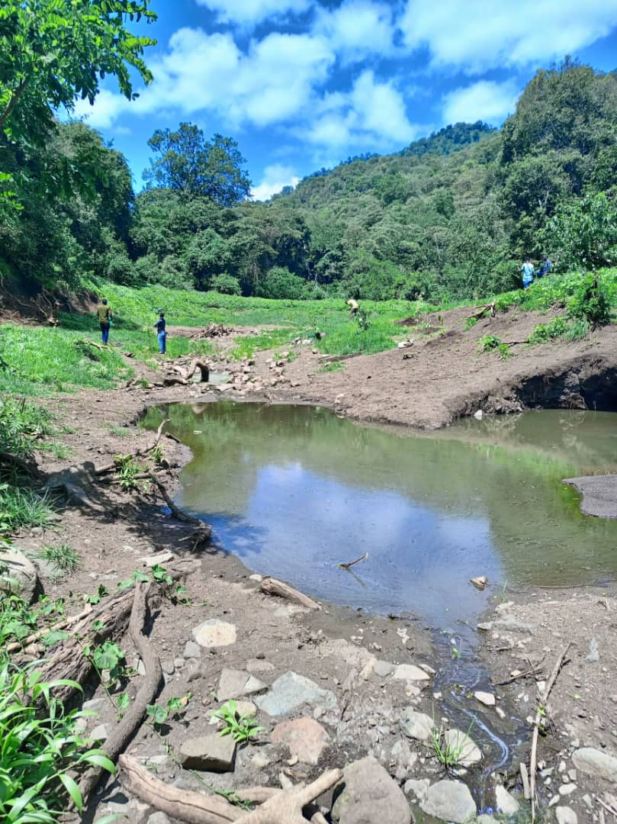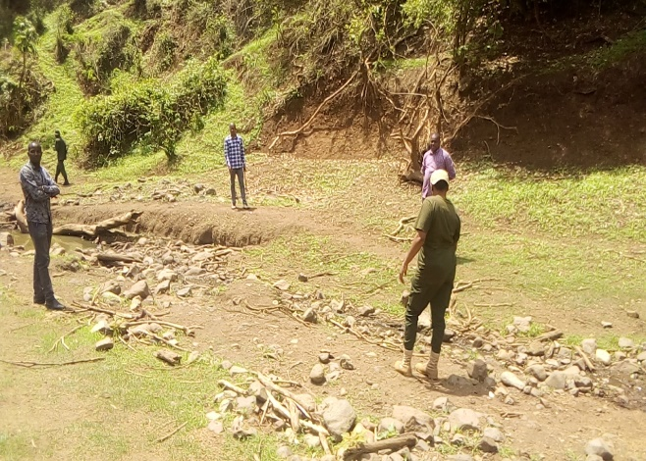

1. 800 trees was planted at Losimingori forest
2. 400 trees was planted at Selela forest
3. 3470 trees was sent to community institutions i.e. primary and secondary school.

The Director of MPDO handing over the trees to the manager of the Tanzania Forestry Authority

The size of the trees we planted in the forest

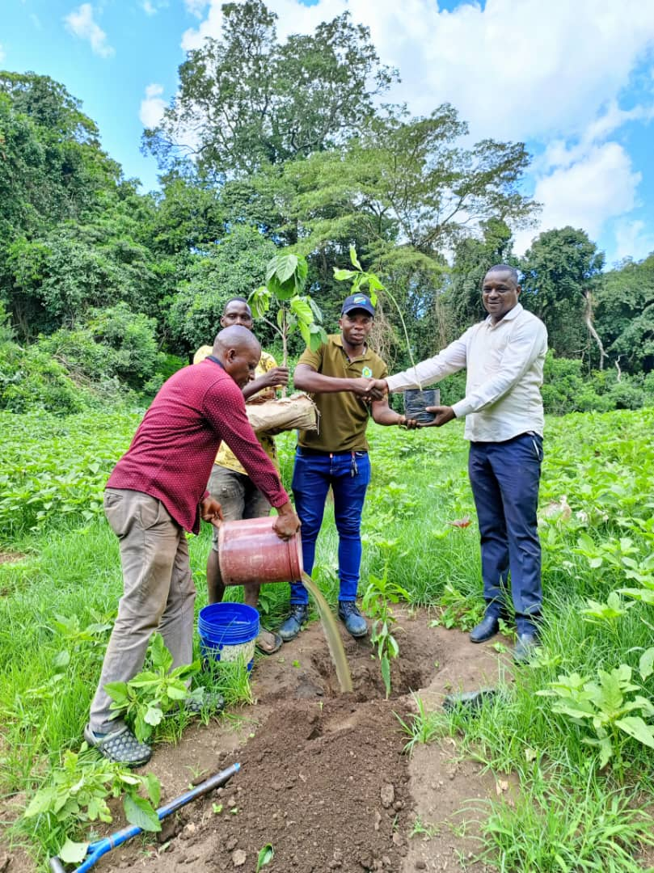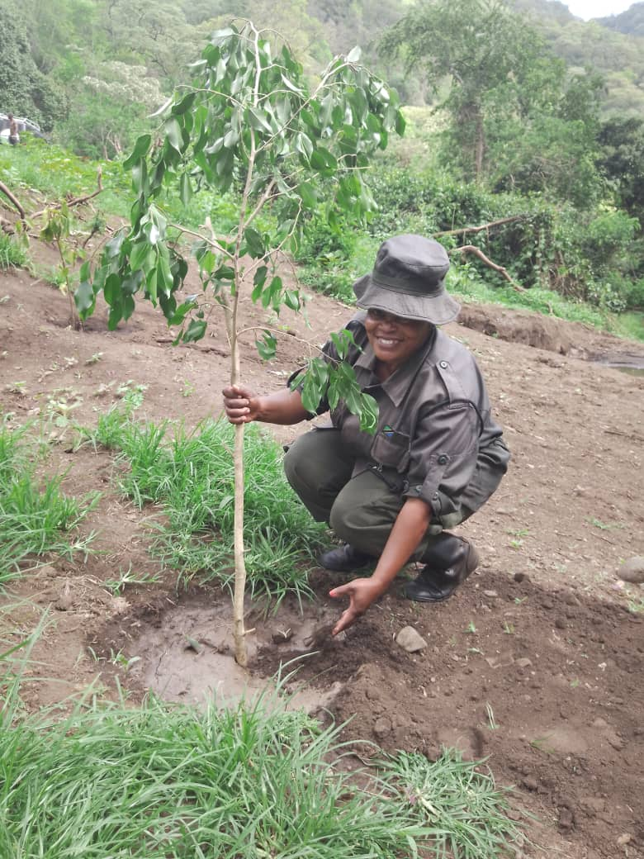

* 1. **Trees Transportation**

This activity has not been done yet because we are waiting for the rain to fall 1.4. Support community work during digging holes for planting trees at community institution. This activity has not been done yet because we are waiting for the rain to fall 2. Handing over beehives and charcoal making machines using waste. MPDO LARETO has handed over 28 beehives to two women groups in Selela ward and Makuyuni ward with the aim of helping them to get rid of themselves economically as well as take care of the environment. The organization has been able to invite the natural resources and environment officer from the district council of Monduli, Ndugu Adil Mwanga who appeared in the news report 11 December 2022 so that he can receive the tanks and hand them over to the groups on behalf of the District Government.

This picture labeled STK 4226 is from Monduli District Council Forest Department. The TSF and Forest Officers from Monduli District Council was working closely with Maasai Pastoralist Development Organization to identify the friendly species required to be planted in the forest managed by TFS.

Again this showing a good relationship between MPDO, government and other stakeholders during project implementation

Purchased trees during its transportation to forest

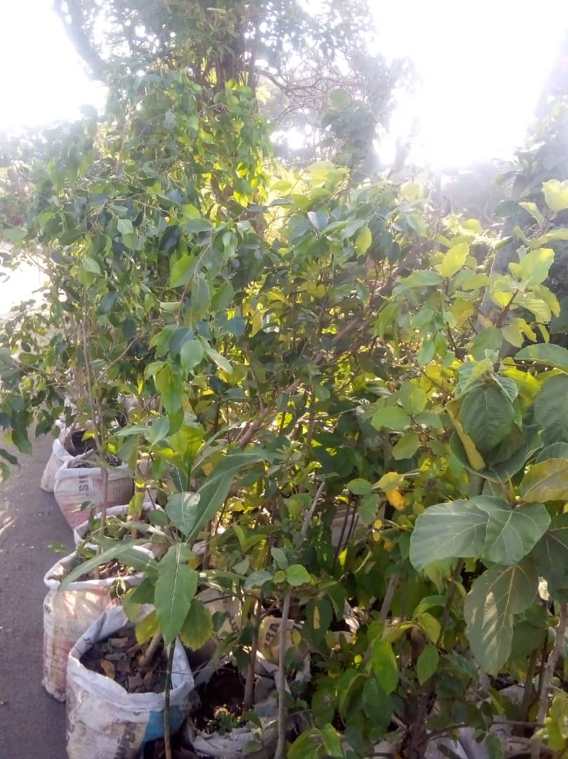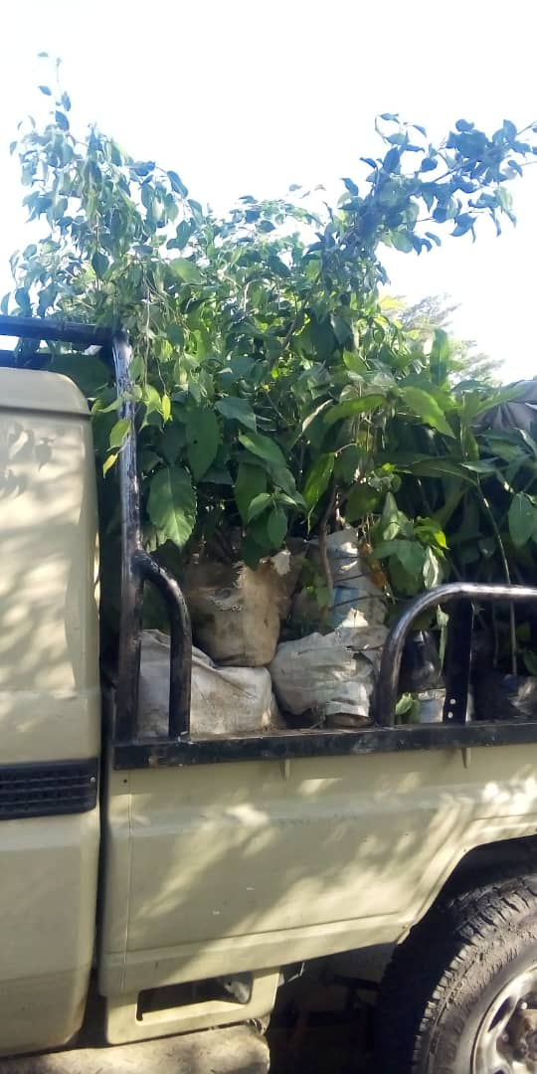



**Results:**

Describe to what extent the objectives of the Agreement were accomplished, in reference to the key results achieved under the GEF SGP OP7 Mandatory Global Environment Indicators and Socio-economic indicators above:

* 7,290 ha of Essimingor and Selela forest are properly preserved, maintaining its biodiversity values and with a degradation rate of less than 1%.
* More than 3,071 people (1,885 men and 1,186 women) receive physical benefits from participation in the management of Essimingor and Selela Forest Reserve.
* 40% Reduced rates of tree cutting and occurrences of forest fires as per disturbance transect data, in areas of Essimingor and Selela, adjacent to the 3 target adjacent villages
* 3 VNRMC are actively working and promoting JFM within the communities, with environmental governance system in place on sustainable basis.

**These results followed by positive and promising indicators.**

* Improvements in water release and quality from PFM areas
* Increasing signs of natural regeneration in degraded areas
* Reduced occurrences of fire
* Reduced village revenue from fines, due to reduction in illegal activities

**Describe the immediate benefits received by the participants and/or the recipient communities:**

The idea of participatory forest management came into practice in the world following the high rate of forest degradation and deforestation in the early 1990s. This approach anticipated to ensure sustainable forest management by involving a large number of stakeholders with different interests, knowledge, expectations and rights. Before the 1990s, the majority of forest in the Country had relied on the centralization approach whereby, the central government managed forests without involving local communities. As a result, forests were under high pressure of deforestation and forest degradation. In response to this challenge, the Rio de Janeiro summit was held in 1992.

**Relationship between PFM and Access to and Use of Information**

Access to and use of information are intertwined. Effective involvement in forest management requires one to be informed and to be informed one has to first get information, be able to use it, be knowledgeable and ultimately increase the participation of stakeholders in forest management activities thereby improving the ability of individuals to make informed decisions. Understanding the roles and responsibilities of all important stakeholders in forest management activities creates self-motivation and willingness of the community to participate in any activity related to forest management. The assumption here is that informed decision would impact on one positively as an individual and as a community member as a whole for the betterment of the community

**Access to and Use of Information for Forest Management**

FAO (2012) argues that, information for forest management is useful in societies as it detects uncertain changes of significant importance in forest management. Accordingly, negative changes brought by climate change, human activities, and natural disturbances in the forests are easily detected with effective monitoring of forest information and timely availability, accessibility and usability of information in communities. This observe that information can create awareness and induce positive achievements in forest planning, management and identification of available opportunities and resources for sustainable forest utilization. However, Isager et al. (2002) state that the problem of decreasing forests is directly linked to inadequate information reaching communities living around forests in rural areas. Information is used for integrated forest planning by creating awareness and acting as a tool for spatial planning in forestry.

**Access to / Use of Information Using Participatory Forest Management in project Villages.**

Monduli remains one of the frontline areas when it comes to practicing participatory forest management. The dissemination of information on this approach started in the early 1990s in Tanzania after conducting pilot studies in Babati and Singida Districts and then rolling out to other forest reserves (Sumbi, 2004). This approach was aimed to rescue forest resources. Iddi et al. (2011) observe that the major problem in Tanzania forest management is not forest degradation and deforestation but the human lack of concern, which is partly attributable to inadequate information, communication, education and rising public awareness in communities living adjacent to and around forest reserves. To address this challenge, communities were encouraged to share information and participate in forest management and conservation by introducing different programmes and campaigns such as participatory forest management, community-based forest management and joint forest management in the early 1990s.

**Sources Consulted for Information on Forest Management**

Sustainable forest management is dependent on the provision of information from different sources including traditional and modern sources.

**Describe long term environment and socio-economic benefits that were achieved by the project:**

* **Forests provide economic benefits.** Through forest we get wood, timber, raw materials, fruits, and honey through beekeeping and medicinal plants, which have significant economic value. The timber is used in construction and making furniture. Wood is also essential in the production of paper. The rubber extracted from trees is used to make several products. Beekeeping used to increase household income.
* **Forests help us combat climate change**. Forests are home to more than half of the world's land-based species of animals, plants and insects. They combat climate change because of their capacity to remove carbon from the atmosphere and store it in the process called forest mitigation.
* **Forests provide clean water through protected water sources**. These benefits is obtained from forest by filtering sediments and other pollutants from the water in the soil before it reaches a water source, such as a stream, lake or river.
* **Availability of clean air.** Trees remove air pollution by the interception of particulate material on plant surfaces and the absorption of gaseous pollutants through the leaf holes.
* **Forests help the wildlife we love thrive**. Plant native species of flowers, trees, and bushes in yard. This gives wild animals’ food, shelter, and a place to raise families. To attract bees to our beehives, we must learn which native plant species are best for bees’ location.
* **Forests help keep community safe.** Forests in our cities help keep us safe. Urban forests have been linked to lower crime rates, a greater sense of public safety, and increased community involvement by residents.
* **Forests help keep us healthy.** While we breathe in the fresh air, we breathe in phytoncides, airborne chemicals that plants give off to protect themselves from insects. Phytoncides have antibacterial and antifungal qualities which help plants fight disease.

**Challenges and Opportunities:**

Despite the substantial efforts made by stakeholders, yet there a number of challenges. This is due to the following constrains which have noted the main hindrance factors for the improvement of sustainability **Sustainable Forest management to secure multiple benefits** issues;

* Forest management is one of the serious problems with diverse challenge; intervention toward addressing it should include working in partnership, different approaches and consolidated effort.
* Low awareness and education on forest management and women empowerment to the society.
* Inadequate financial resources: Resources are limited while human wants are unlimited, This caused by minimal budget allocated for project planned activities.The deficit budget from the government and other partners has great impact to the sustainability of forest management. We challenged to educate the community we are working with because of financial constraints.
* Forest management and women empowerment programs/ project to be continued implemented by Ministries and organization without being integrated as it should have been. This slows down the rate of development and effectiveness as other related institution, organization and society think that, it’s ministerial and related organization role.
* Transport – some areas are very remote to extent that sometime may hinder MPDO to fail to meet their required targeted audience.
* Climate change has affected most of our work planning activities as most of our stakeholders are not available all the time.
* Language barrier – most of participant from pilot area do not master Swahili language hence sometimes may force native languages to be used to deliver the massage to community.
* Cultural belief – this is happening especially to women hence they are bounded to make their own decision on which it give hardness to understand their rights.

**Key lesson learned:**

Training for all beneficiaries or target group bring effectiveness in the service which is good to enable justice for all also the team work between the government and civil societies remained to effective and for great value. Some few things have learnt during activities implementation in all wards covered as indicated below;

* Networking and alliance building is of key for sustainable forest management movement thus encourage as it values towards realization of the goal.
* Participation and commitment on Key stakeholders including the Government, donors and others is paramount; especially in allocating resources on forest management programmes.
* Forest management and beekeeping activities minimizing start-up risk to participants in remote forest communities is key to increasing the likelihood of continued engagement and realizing economic benefits.
* Forest conservation process must be inclusive, locally relevant and appropriate in order to sustain community participation.
* Tanzania Forest Services Agency (TFS) and community clusters are important support structures that contribute to the sustainability and scaling up of forest management and beekeeping activities.
* Communal implementation challenges can hamper the potential success of beekeeping so adaptive management and a strong monitoring and evaluation system are critical need to address challenges in timely manner.
* Support from the government, CSOs, and other related field should be encouraged to facilitate join forest management and the needy groups for forest resources management.
* There is a need of creating proper guidelines to ensure cooperation and coordination among various sectors in undertaking forest implementation plan to community.
* If the Government is effectively involved community on land rights and forest management issues will be pushed more successfully and easily.
* Political will is supportive made the project to reach its climax of during its implementation.
* All stakeholders have recognized that unity within grassroots level representatives is needed at large extend.
* Unequal participation in leadership between men and women’s hence women where 23% while men are 77% of the whole number of participants.
* Beekeeping as a conservation initiative must be part of other complementary strategies to effectively change behavior and reduce threats to biodiversity.

**Recommendations**

Since it is acknowledged that access to and use of information is critical in forest management, it is recommended that the flow of information be closely monitored to minimize any obstructions. Communicated information should be simple and easy to understand for the majority of the people, especially the targeted group (in rural areas) who cannot understand scientific information. Secondly, since general mass media, groups such as youth and women, and awareness campaigns are the real information transmission belts in communities, they should be effectively used by forest agencies for positive impacts. Forest agencies should consider taking advantage of technological advancement in communication (mobile phones, internet, emails and social networks, broadcast media websites) when developing communication strategies.

The implemented project supported by UNDP/SGP has not reached to the desired goal due to big forest demand and minimal grant received from our donor. Our recommendation is to request UNDP/SGP to add some funds for the implementing organization to ensure that we reaches the high level of project goal.

**Conclusion**

The importance of participatory forest management, challenges encountered in participatory and joint forest management approaches during project implementation has brought good relationship between community and other forest stakeholders like TFS and TAWA to similar understanding. The high rate of deforestation and forest degradation has almost halved the forest cover mainly due to illegal activities in Losimingori forest, which to some extent is attributable to inadequate access to and use of information for forest management. After all, information establishes an important resource for the development in any forest. However, the extent to which access and use of information for forest and agricultural management by rural communities is not clearly demonstrated. This implies that there is poor transfer and use of information and knowledge by forest stakeholders in rural areas to meet the information needs required in effective forest management. Inadequate access to and use of information leads to the poor formulation and implementation of active sustainable forest management plans, strategies, and conflict over forest resources use.

Date:____________________ Proposed by:__________________

**Annex F:**

**Final Financial Report**

Date: 28th February 2023

Project Number: TAN/SGP/OP6/Y5/ICCA-GSI/2021/05

Project Title: **Sustainable Forest management to secure multiple benefits in Essimingor and Selela forests conservation in Monduli.**

Name of the Local Organization: MPDO - LARETO

Total Amount of Funds Under the Agreement: TZS 59,853,600.00

Date of signature of the Agreement: 18/10/2021

**FOR THE ENTIRE PERIOD OF THE GRANT**

|  |  |  |  |
| --- | --- | --- | --- |
| **General category of expenditures** | **Global Budget** | **Expenditures** | **Balance** |
| Manpower/labor | 4,433,600 | 4,433,600 | **-** |
| Training/Seminar/Workshops, etc.. | 27,570,000 | 27,570,000 | **-** |
| Contracts | 27,850,000 | 27,850,000 | **-** |
| Equipment/Furniture | **-** | **-** | **-** |
| Others (specify) | **-** | **-** | **-** |
| Miscellaneous |  |  |  |
| **Total** | **59,853,600/=** | **59,853,600/=** |  |

Total Budget approved: USD25, 903

Funds advanced USD25, 903

Amount of expenditures USD25, 903

Funds requested USD25, 903

Balance (if any exists): NILL

Certified by:________________

Name and signature of the Representative of the Local Organization

The Local Organization is responsible for compiling and providing all supporting documentation or information related to this report at the request of UNOPS.